Atal Behari Vajpayee
Statesman in waiting
Even though he has grown up in the Sangh, the impress of
Nehruvian liberalism on him is only too pronounced

By Bhaskar Roy

SILHOUETTE
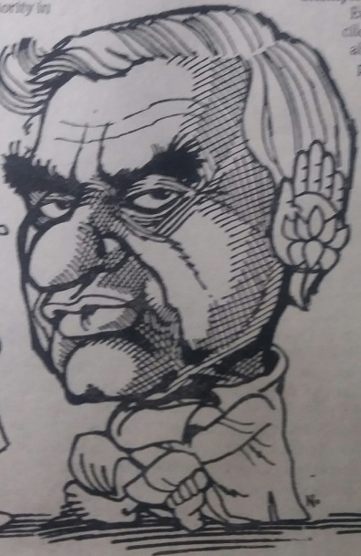
The day after he made the controversial remark in the Lok Sabha bailing out Prime Minister PV Narasimha Rao from a difficult situation, Atal Behari Vajpayee shared the platform with the extreme-right phalanx of the Hindutva proponents at a book-release function. In the same row were sitting RSS Sarsanghachalak Rajendra Singh, BJP president LK Advani and former party president Murli Manohar Joshi.
As the audience for the launch of BJP MP Vijay Kumar Malhotra’s book Lotus was mainly drawn from the Sangh Parivar, the tension was palpable. An invisible line seemed to separate Vajpayee from the others. However, the moment he took the mike the mood changed. Said he, “I am told Malhotraji worked on this magnificent book when he was away from Parliament. If we have to get another book from him, Advaniji knows what to do.” Peals of laughter that followed the remark dissipated the undercurrent of tension between him and the fellow travellers. Indeed, for a politician who has spent 35 years of his life in Parliament interacting with titans like Jawaharlal Nehru and Indira Gandhi, the straitjacket of a strict party line has begun to wear thin. The man has grown larger in perceptions and experience than what the rigour of party discipline could accommodate. But the party has no choice either.
Vajpayee recalled somewhere the parting words of Jan Sangh founder Syama Prasad Mukherjee before the latter’s mysterious death in Kashmir in 1953: “Go back and carry on the unfinished work.” To be true to his mentor, Vajpayee has spent his entire adult life in the saffron brotherhood. His integrity has never been questioned. But for an acutely sensitive person who is essentially a poet, the dead load of a sharply defined ideology has often proved taxing. Asked about such a perceived incompatibility, he once remarked, “Jaye to jaye kahan” (Where do I go if I decide to leave this party?).
That is quintessentially the dilemma of a liberal. He has grown up in the Sangh Parivar. But the impress of Nehruvian liberalism on him is only too pronounced. He is still the best crowd-puller for his party. His speeches often surpass the border of rhetoric and acquire literary qualities. But at the same time, he is uncomfortable with the strident Hindutva campaign of the party during 1989-91. Says Congress spokesman VN Gadgil: “Vajpayee is basically a liberal but a hopeless minority in his party – a nationalist trying to rise above the party line.” At one level, he is seen as a shrewd politician who has charted an individualistic course for himself without vying for posts and positions in his party. Leaving the narrow alley of party politics he successfully carved out a space on the larger canvas of national affairs. But again, he did not forsake his party. With élan he straddles the revivalist Hindutva bandwagon and the broader, subtler world of statesmanship. In Indian politics this is a unique experiment which no one before Vajpayee has attempted.
Even the BJP seems reconciled to its leader’s rise far above the demands of the party line. Says party spokeswoman Sushma Swaraj: “He has attained the stature of a statesman. If it is necessary to rise above the party interest he does not hesitate to do so. Geneva is the latest example.”
What has lent a different dimension to Vajpayee’s existence in the grey area between Opposition politics and statesmanship is the absence of any expectation on his part. One of the most successful foreign ministers, his position is much higher than that of any other practising politician. His proximity to Narasimha Rao does not imply promise of any reward.
At the same time he has not declined any responsibility bestowed by the party. In every election, he maintains a gruelling campaign schedule criss-crossing the country and weaving webs of words again and again.
What Vajpayee baulks at is the tendency to score political points beyond a level where it comes in conflict with national interest. His remark that it was too late to call off the Prime Minister’s US visit was not the first of its kind. Soon after VP Singh took over as Prime Minister in 1989, Vajpayee surprised many party colleagues by making an appeal for the postponement of Vishwa Hindu Parishad’s Ayodhya movement. After the Bangladesh War Vajpayee’s effusive praise of Indira Gandhi proved embarrassing for his party men.
In the evening of an eventful political career Vajpayee has met the challenge of not repeating himself and also not compromising his intellectual integrity. He has outgrown the limitations of an average party politician without disowning his duty. He has taken up the role of a national leader minus the trappings of office and more importantly without letting down his primary constituency.

